

|  |
| --- |
| Dish And The Spoon Prototype |
| 03/10/18 18:21 |
| **Author:** John Doe  **File name:** Dish And The Spoon Prototype.vp  **Version** 1.0 |

|  |
| --- |
| Site Map |
|  |

|  |
| --- |
|  |

01. Site Map / Dish And The Spoon Prototype 

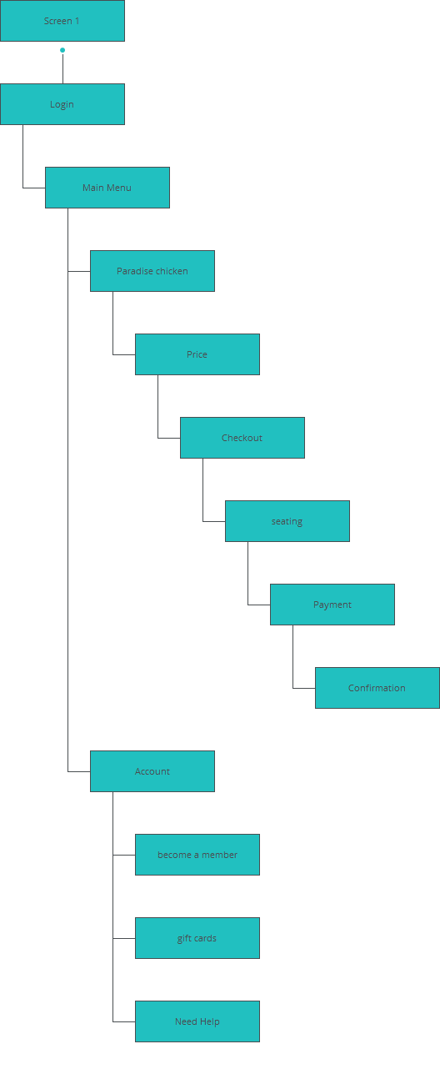

|  |
| --- |
| Screens |
|  |

|  |
| --- |
|  |

02. Screens / Dish And The Spoon Prototype 

Screen 1

|  |
| --- |
|  |

Interactions

|  |  |
| --- | --- |
| 1 | **on Click:** goes to 'Login' with effect: pop 🡪 |

02. Screens / Dish And The Spoon Prototype 

Login

|  |
| --- |
|  |

Interactions

|  |  |
| --- | --- |
| 2 | **on Click:** goes to 'Main Menu' with effect: pop 🡪 |
| 3 | **on Click:** goes to 'Screen 1' with effect: fade 🡪 |

02. Screens / Dish And The Spoon Prototype 

Main Menu

|  |
| --- |
|  |

Interactions

|  |  |
| --- | --- |
| 4 | **on Click:** goes to 'Login' with effect: fade 🡪 |
| 5 | **on Click:** goes to 'Paradise chicken' with effect: pop 🡪 |
| 6 | **on Click:** goes to 'Account' 🡪 |

02. Screens / Dish And The Spoon Prototype 

Paradise chicken

|  |
| --- |
|  |

Interactions

|  |  |
| --- | --- |
| 7 | **on Click:** goes to 'Main Menu' with effect: fade 🡪 |
| 8 | **on Click:** goes to 'Price' with effect: pop 🡪 |

02. Screens / Dish And The Spoon Prototype 

Price

|  |
| --- |
|  |

Interactions

|  |  |
| --- | --- |
| 9 | **on Click:** goes to 'Checkout' with effect: pop 🡪 |
| 10 | **on Click:** goes to 'Paradise chicken' with effect: fade 🡪 |

02. Screens / Dish And The Spoon Prototype 

Checkout

|  |
| --- |
|  |

Interactions

|  |  |
| --- | --- |
| 11 | **on Click:** goes to 'Price' with effect: fade 🡪 |
| 12 | **on Click:** goes to 'seating' with effect: pop 🡪 |

02. Screens / Dish And The Spoon Prototype 

seating

|  |
| --- |
|  |

Interactions

|  |  |
| --- | --- |
| 13 | **on Click:** goes to 'Checkout' with effect: fade 🡪 |
| 14 | **on Click:** goes to 'Payment' with effect: pop 🡪 |

02. Screens / Dish And The Spoon Prototype 

Payment

|  |
| --- |
|  |

Interactions

|  |  |
| --- | --- |
| 15 | **on Click:** goes to 'seating' with effect: fade 🡪 |
| 16 | **on Click:** goes to 'Confirmation' with effect: pop 🡪 |

02. Screens / Dish And The Spoon Prototype 

Confirmation

|  |
| --- |
|  |

Interactions

|  |  |
| --- | --- |
| 17 | **on Click:** goes to 'Main Menu' with effect: pop 🡪 |
| 18 | **on Click:** goes to 'Main Menu' with effect: fade 🡪 |

02. Screens / Dish And The Spoon Prototype 

Account

|  |
| --- |
|  |

Interactions

|  |  |
| --- | --- |
| 19 | **on Click:** goes to 'Main Menu' with effect: fade 🡪 |
| 20 | **on Click:** goes to 'become a member' with effect: pop 🡪 |
| 21 | **on Click:** goes to 'gift cards' with effect: pop 🡪 |
| 22 | **on Click:** goes to 'Need Help' with effect: pop 🡪 |

02. Screens / Dish And The Spoon Prototype 

become a member

|  |
| --- |
|  |

Interactions

|  |  |
| --- | --- |
| 23 | **on Click:** goes to 'Account' with effect: fade 🡪 |

02. Screens / Dish And The Spoon Prototype 

gift cards

|  |
| --- |
|  |

Interactions

|  |  |
| --- | --- |
| 24 | **on Click:** goes to 'Account' with effect: fade 🡪 |

02. Screens / Dish And The Spoon Prototype 

Need Help

|  |
| --- |
|  |

Interactions

|  |  |
| --- | --- |
| 25 | **on Click:** goes to 'Account' with effect: fade 🡪 |

|  |
| --- |
| Templates |
|  |

|  |
| --- |
|  |

03. Templates / Dish And The Spoon Prototype 

Template 1

|  |
| --- |
|  |

|  |
| --- |
| Scenarios |
|  |

|  |
| --- |
|  |

04. Scenarios / Dish And The Spoon Prototype 

default

|  |
| --- |
|  |